MARDEN-KANE, INC.
AFFIDAVIT OF ELIGIBILITY AND RELEASE

CITY OF: Medellín COUNTRY OF: Colombia

I, Jorge Ocampo Rendón, being duly sworn, say I am 32 years of age.

Home Telephone Number: (57) 3005766422 Email: jiorendon@gmail.com

I reside at: Calle 23 Sur # 27- 43 apto 106 Envigado / Antioquia / Colombia 055420
(Street Address) (City/State/Region) (Postal Code)
I am submitting this affidavit to Marden-Kane, Inc. with the understanding that it will be relied upon to determine my eligibility in the Google Dev Art 2014 sponsored by Google, Inc.

I represent that I have complied with all the rules and regulations of this promotion and that I have perpetrated no fraud or deception in entering or in claiming any prize. I further represent that I or members of my immediate household are not employees of the sponsor, its affiliates, subsidiaries, advertising agencies, or of Marden-Kane, Inc., nor am I or any family member in my immediate household, connected with them in any way.

I further understand that if my entry is selected as a winner that I hereby, for myself, my heirs, executor and administrators, waive and release any and all rights and claims I may have against Google, Inc. and Marden-Kane, Inc. for any matter, cause or thing whatsoever with respect to, or arising as a result of, the prize that I may win in the Google Dev Art 2014. I further understand that if I am awarded a prize, any taxes are my responsibility.

I hereby state: I am employed by: Fundación Universitaria Bellas Artes

Address:
Cra. 42 a Nº 48 86 Medellín / Antioquia / Colombia 050016
(Street Address) (City/State/Region) (Postal Code)

Telephone Number: ( 57 - 4 ) 4447787 option 1 Ext. 3112

I further state: The family members and individuals living in my immediate household, whether related or not, are employed by:
Name of Family Member: Relationship to Entrant: Employed By:

Ana Maria Vanegas Girlfriend

____________________________ ___________________ ______________________________________________
(If additional space is required, please use the reverse side of this form.)

I agree to return any prize which may be awarded to me if any statement made by me in this affidavit is false.

**************************************************************************************************
I grant permission for the use of my name, city, state, region, country and/or photograph for advertising and promotional purposes in conjunction with this promotion without additional compensation.

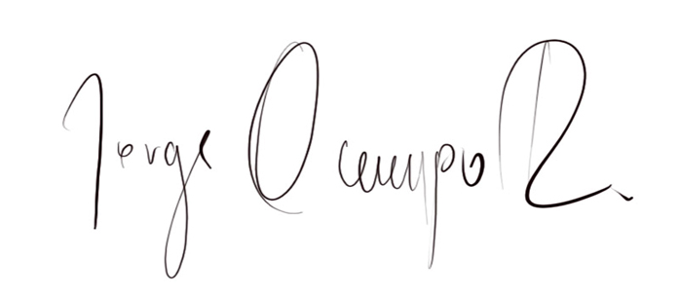

Signed: _______________________________________
(Signature of parent or guardian if Entrant is under the age of majority in his/her jurisdiction of residence)

